## Installation of MCR

#### Download the MCR and Docker Images for Fortify DAST 23.1

1. Download the script from https://get.mirantis.com/install.ps1
2. Allow downloaded script files to run in the current session in powershell

PS> Set-ExecutionPolicy -ExecutionPolicy RemoteSigned -Force -Scope Process;

1. Run the installation script with the **-DownloadOnly** parameter. As per the parameter name, this action only downloads the zip file (no installation is performed).

PS> .\<installation-script> -DownloadOnly

1. Copy the installation script and the installation zip file over to the air-gapped machine (PR Server) and run the install with the **-Offline** parameter.

PS> .\<installation-script> -Offline

1. Start the Docker Service Docker Engine from services.msc
2. A restart is required for changes to take place.

PS> Restart-Computer

1. After restart Download the following images using docker pull login Creds elfskinnedjoyce:27febrauary@1997

PS> docker login

PS> docker pull fortifydocker/scancentral-dast-api:23.1  
 PS> docker pull fortifydocker/scancentral-dast-globalservice:23.1  
 PS> docker pull fortifydocker/webinspect:23.1

1. Extract the contents of scancentral-dast-config.tar from the DASTConfigurationTool File
2. Locate the file **fk\*** Folder
3. Extract the layer.tar file from the folder
4. Navigate to **.\app\**
5. Copy the **DefaultData.zip** file to a Different Location (for Database Seeding)
6. Create a folder in **C:\Config**
7. Copy the **.YAML** file from the downloaded file to the Config folder
8. Edit the **YAML** File with the proper parameter for URL and Credentials
9. Create the configuration file with following command

PS> DAST.ConfigurationTool.exe configureEnvironment -mode autodeploy -settingFile <config.yaml> -outputDirectory C:\Config\

1. The Database Seeding Process will start. **(Will take around 40 mins)**
2. Open the output Folder and Extract the content of **scancentral-dast-windows.zip**
3. Run the **start-containers.ps1 script as Administrator in powershell.
4. Wait till all the containers are up and running

PS> docker ps

1. Login Fortify SSC with Administrator Credentials
2. Navigate to **ADMINSITRATION > Configuration > Scancentral DAST**
3. Enable the ScanCentral DAST check box
4. Enter the DAST Controller URL and click **SAVE**
5. Navigate to **SCANCENTRAL > DAST** to Load the SCANCENTRAL DAST Controller

#### Installation of WebInspect 23.1

1. Double-click the .exe or .msi file to start the Setup Wizard.

* The Welcome to the Micro Focus WebInspect Setup Wizard window appears.
* 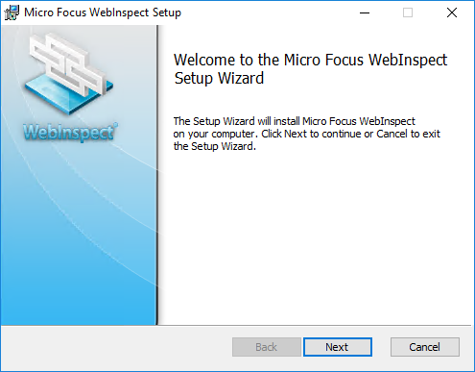
* 01_Welcome_NoVer

1. Click **Next.**

* The End‑User License Agreement window appears.

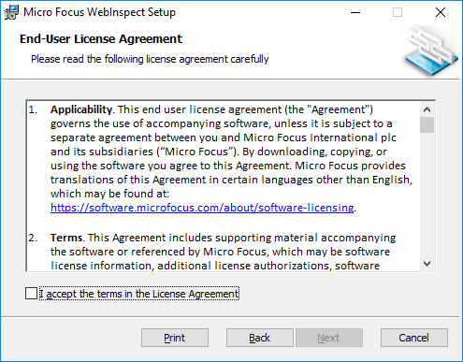

02_EULA_NoVer

1. Review the license agreement. If you accept it, select the check box and click **Next**; otherwise click **Cancel**.

* If you accept the license agreement, the Destination Folder window appears.
* 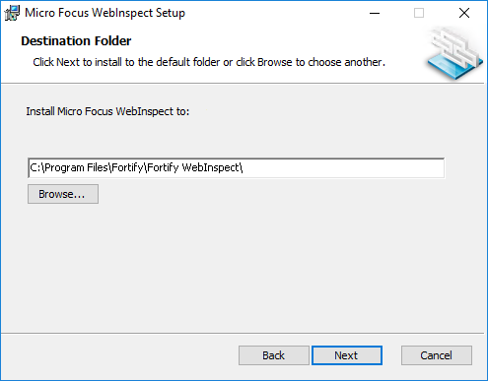
* 03_DestFolder_NoVer

1. In the Destination Folder window, do one of the following:
   * If you are installing Fortify WebInspect as a sensor for Micro Focus Fortify WebInspect Enterprise, do *not* make any changes to the default Destination Folder. Click **Next**.
   * C:\Program Files\Fortify\Fortify WebInspect
   * Otherwise, you can accept the default Destination Folder or choose a different folder into which you want to install the software. Click **Next**.
   * The Sensor Configuration window appears.
   * 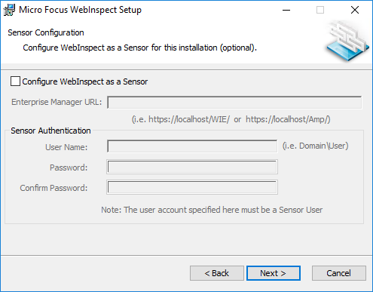
   * 04_Sensor_NoVer
2. To install Fortify WebInspect as a sensor:
   1. In the **Configure WebInspect as a Sensor for this installation (optional)** area, select **Configure WebInspect as a Sensor**.
   2. Enter the **Enterprise Manager URL**, that is, the URL of Fortify WebInspect Enterprise manager.
   3. In the Sensor Authentication group, enter the Windows account credentials for this sensor.

* For important information about installing Fortify WebInspect as a sensor and configuring it to work with Fortify WebInspect Enterprise, see the *Micro Focus Fortify WebInspect Enterprise Installation and Implementation Guide*.

1. Click **Next**.

* The Ready to install Micro Focus WebInspect window appears. 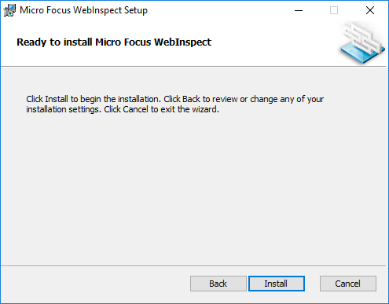

1. Click **Install**.

* When the installation process is complete, the Completed the Micro Focus WebInspect Setup Wizard window appears. 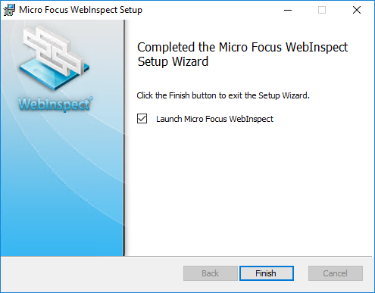

1. Select **Launch Fortify WebInspect** and click **Finish**.

* The Setup Wizard closes and Fortify WebInspect launches.

#### Configuration of DAST Scanner Service

1. Download the **ScannerService.zip** file from the Fortify ScanCentral DAST software download package.
2. Install **.NET Framework 7 SDK** from
3. Create a folder in **C:\ScannerService**
4. Extract the **ScannerService.zip** file to any directory, such as the following: **C:\ScannerService**
5. Place the **appsettings.json** file that the ScanCentral DAST Configuration Tool created in the same directory, replacing the existing file.
6. Run **cmd** as Administrator and run the following command.

> sc create ScannerWorkerService binpath= "C:\ScannerService .\DAST.ScannerWorkerService.exe" start= auto depend= "WebInspect API" displayname= "WebInspect DAST Scanner Worker Service"

1. The **ScannerWorkerService** is created and automatically starts each time the computer is restarted.